**Progress Report**

**Final name of the System:**

**STUDENT’S PROFILE SYSTEM**

**Group Members:   
Joulze Ann Bartolabac**

**Kent Base**

**Mary Grace Bocaya**

**Christian Dune Deocariza**

**Angelo David Castuera**

***As of May 31, 2020***

**What is the System all about?**

**It’s about the student’s profile system which allows the teacher to input information about the student such as name, age, gender, address, student number etc.**

**Objectives:**

**To easy access to student’s information.**

**Target:**

**Teachers/Instructors/Professors**

**Inspiration of the System:**

**Because of multiple sections handled by one teacher, it’s hassle for them to memorize and organize all the information of their students. That is why we were motivated to create this system to make it easier for the teacher to organize the student’s information. Because we are in the midst of a pandemic, we may be able to use our technology to monitor students as a substitute. Teachers still have access to their students' information, even if we are using distant learning.**

**Model used:**

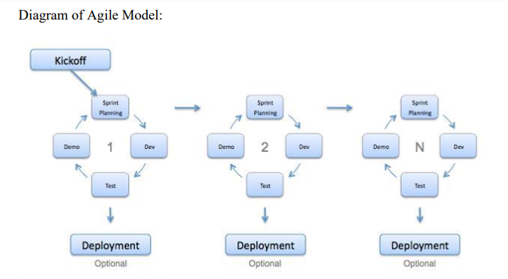

**Flows of making the System:**

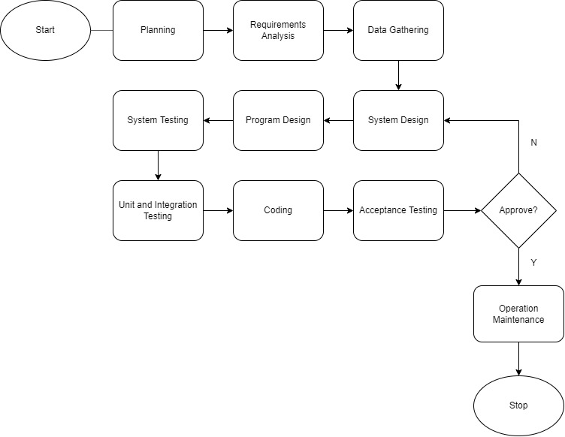

**Initial Design of the System**

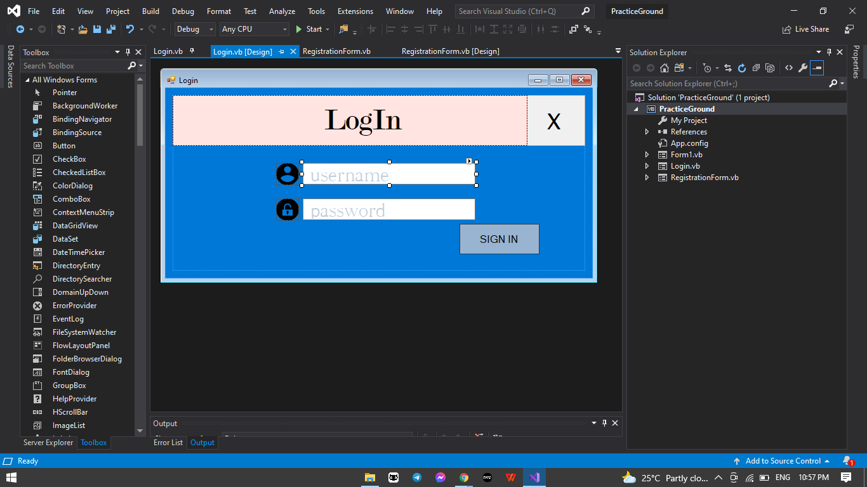**Log In Module:**

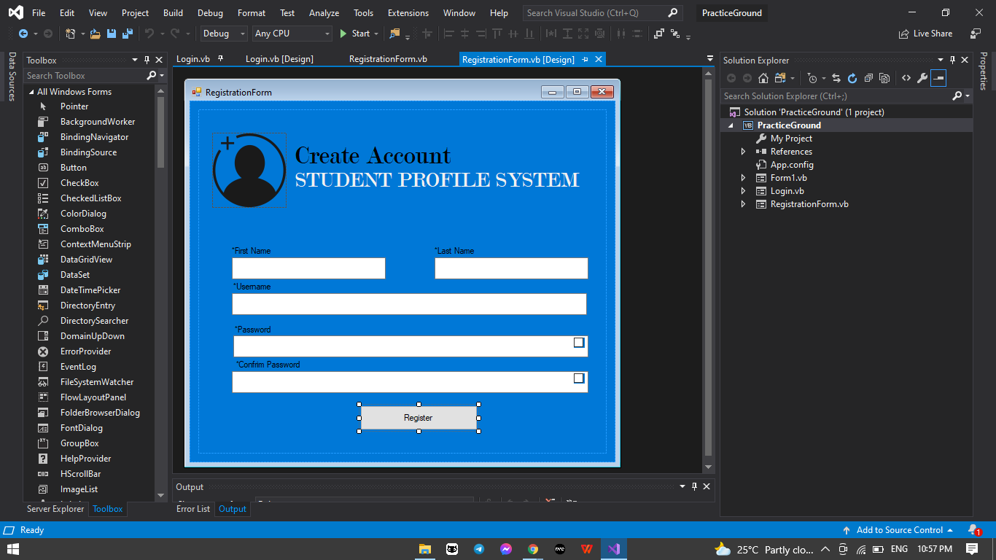**Registration Module:**

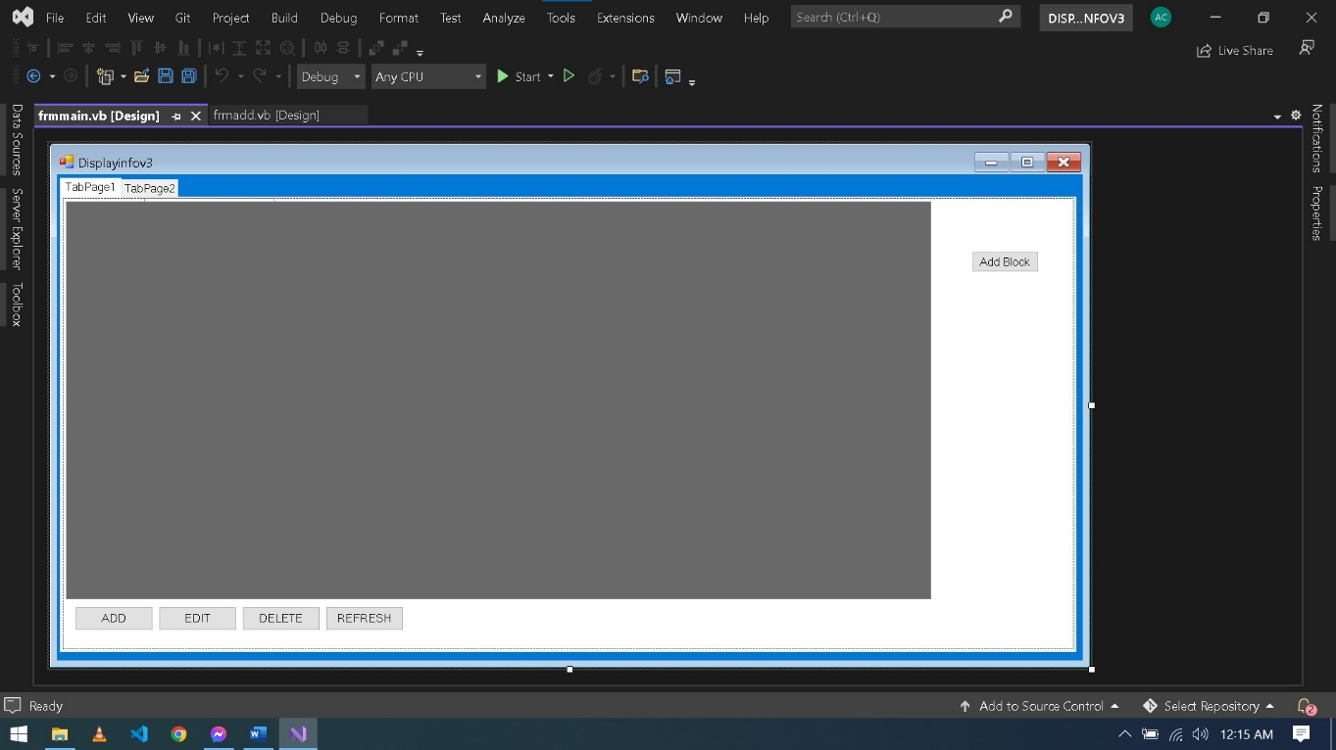**Display of Information Module:**

**Input of Information Module:**

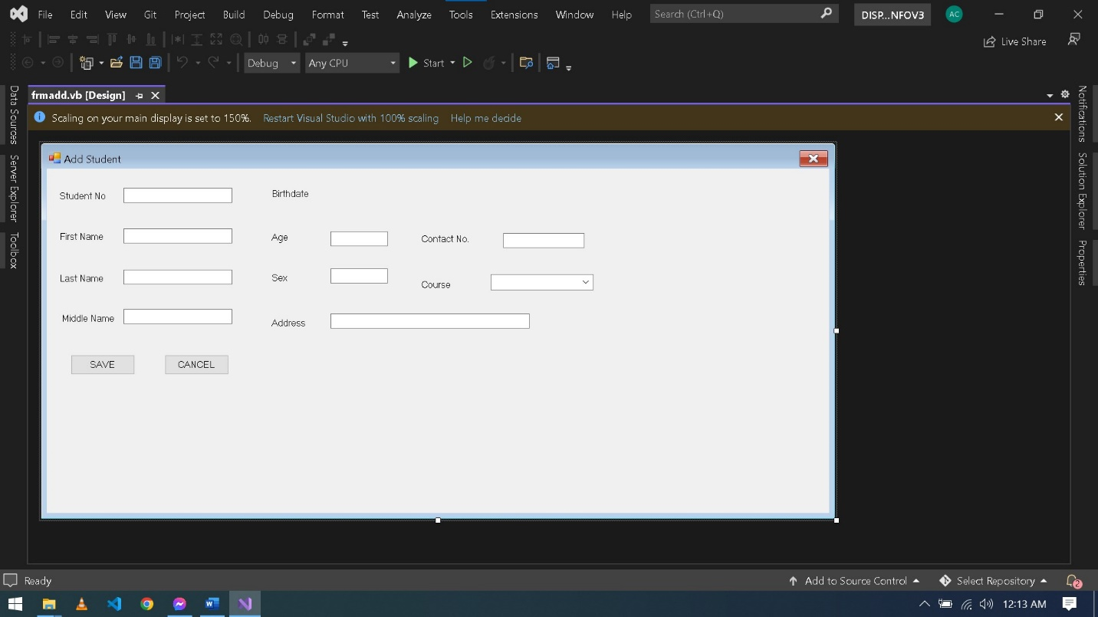

**Buttons Module:**

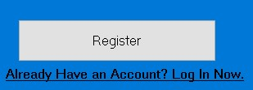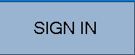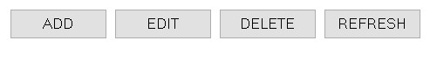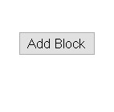

Final Design of the System:

Log in Module:

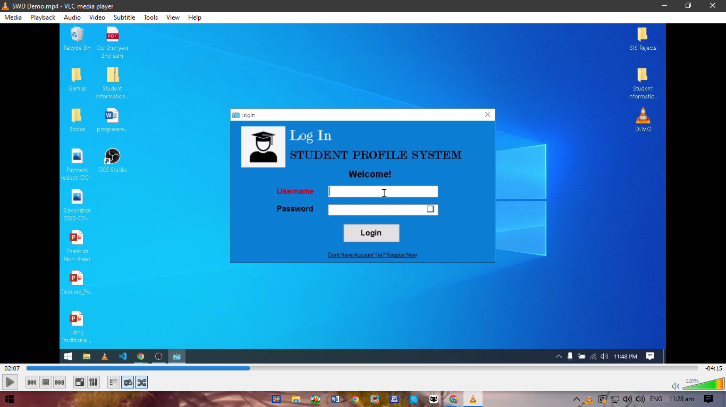

Registration Module:

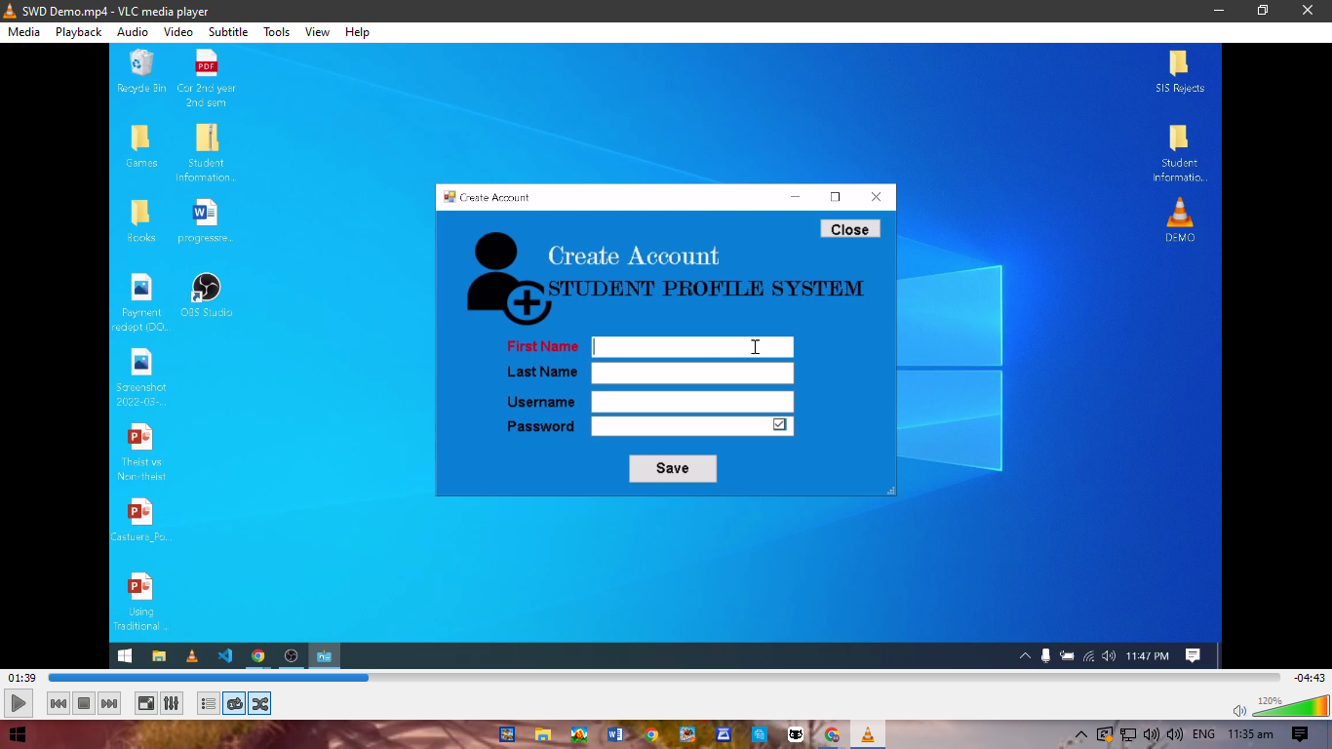

Displaying Of Information Module:

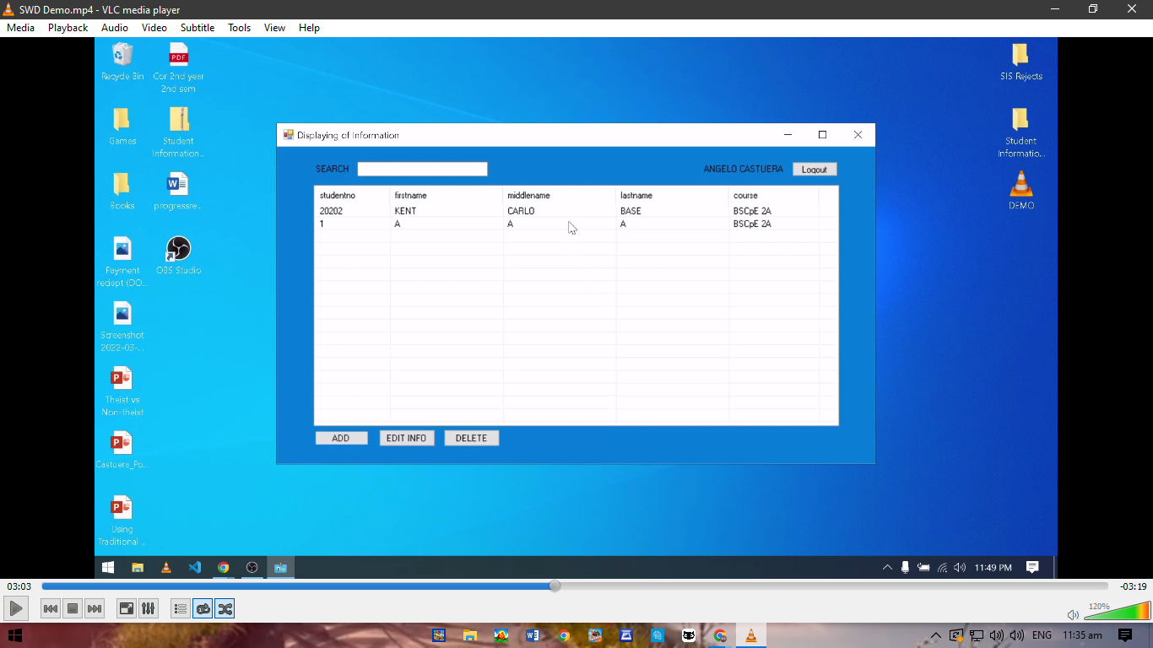

Input of Information Module:

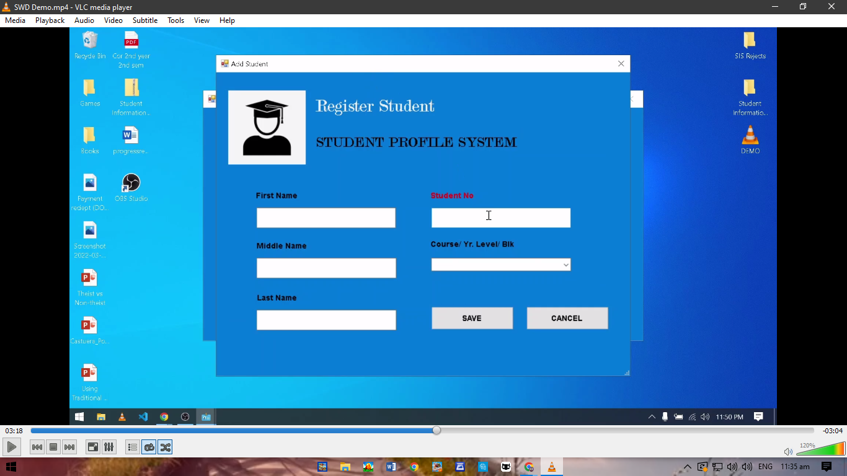

Buttons Module:

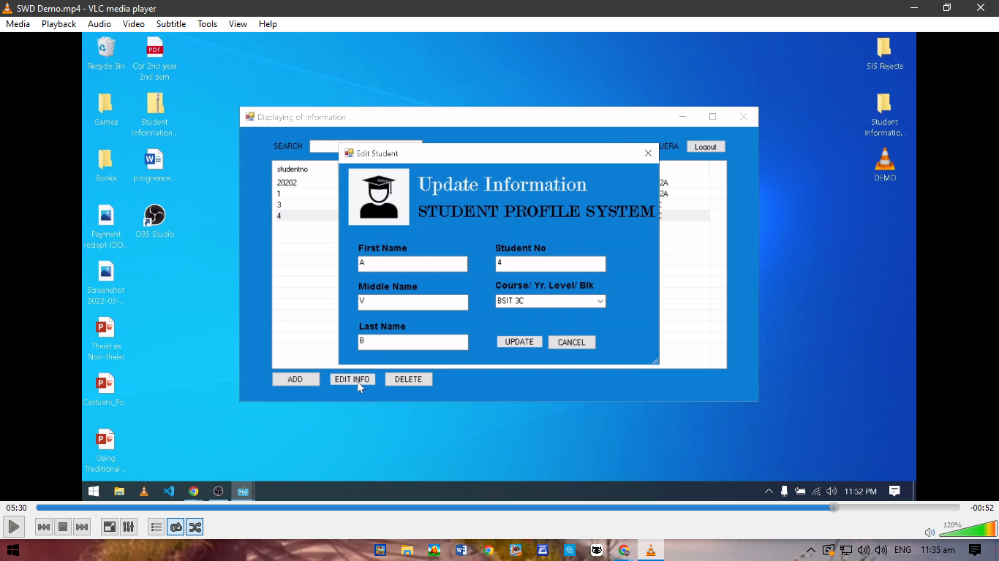

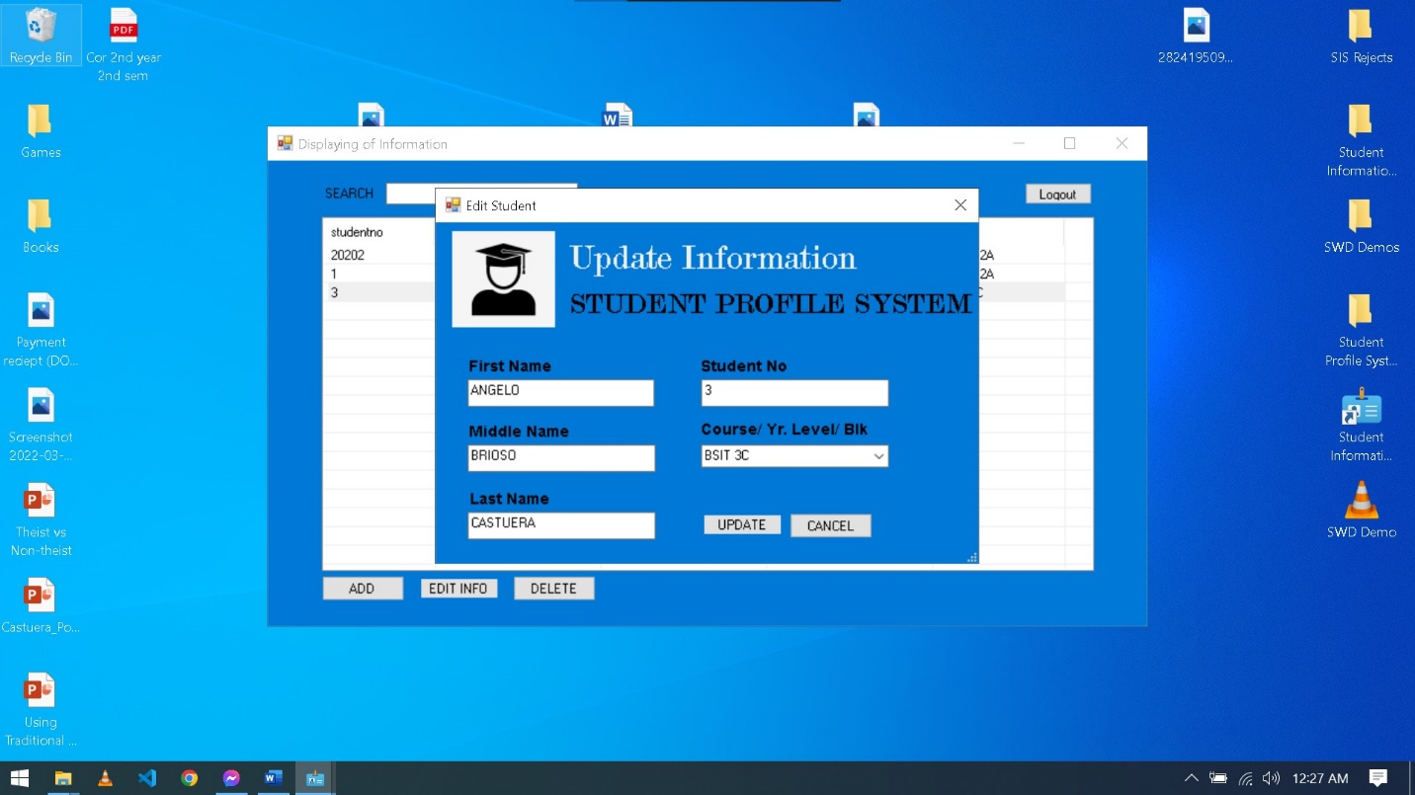

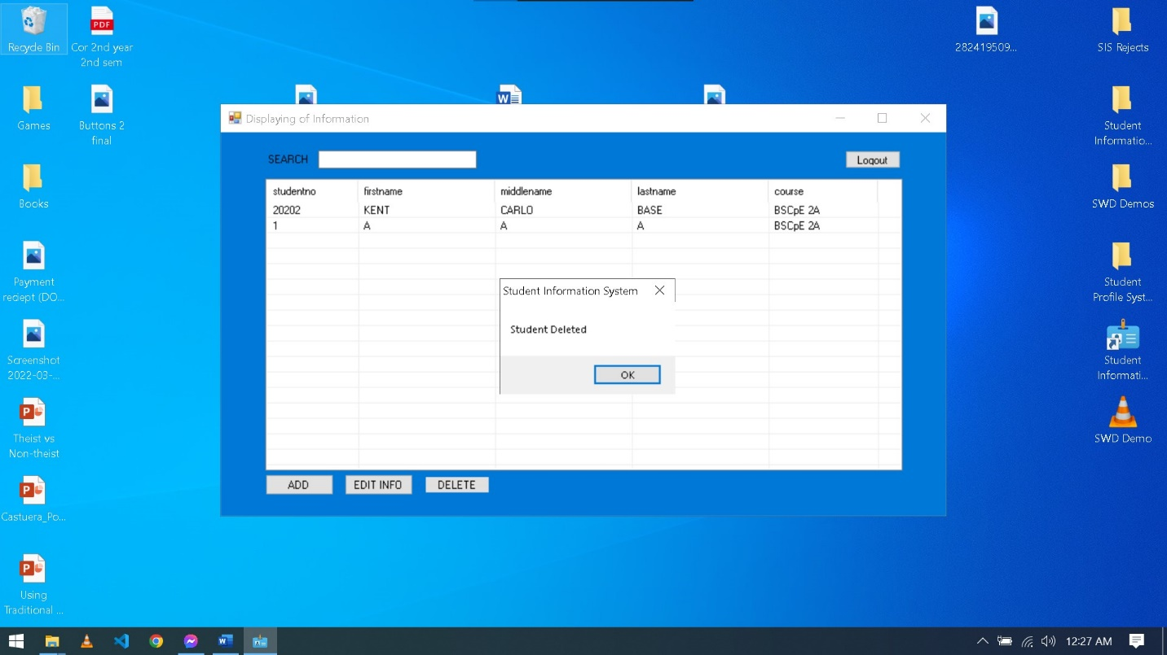



Flowchart:

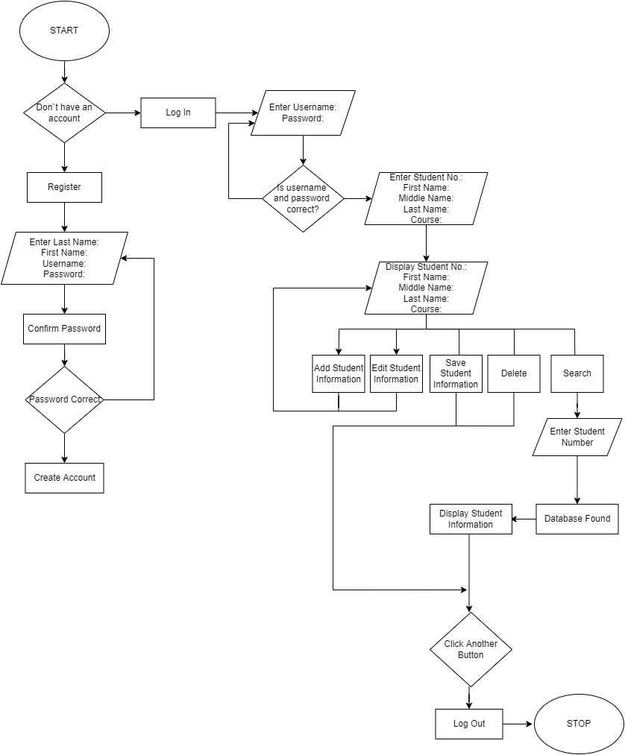

HIPO (VTOC):

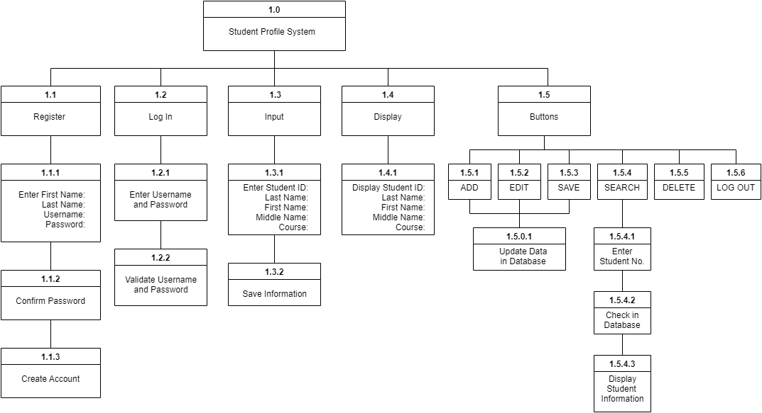

Use Case:

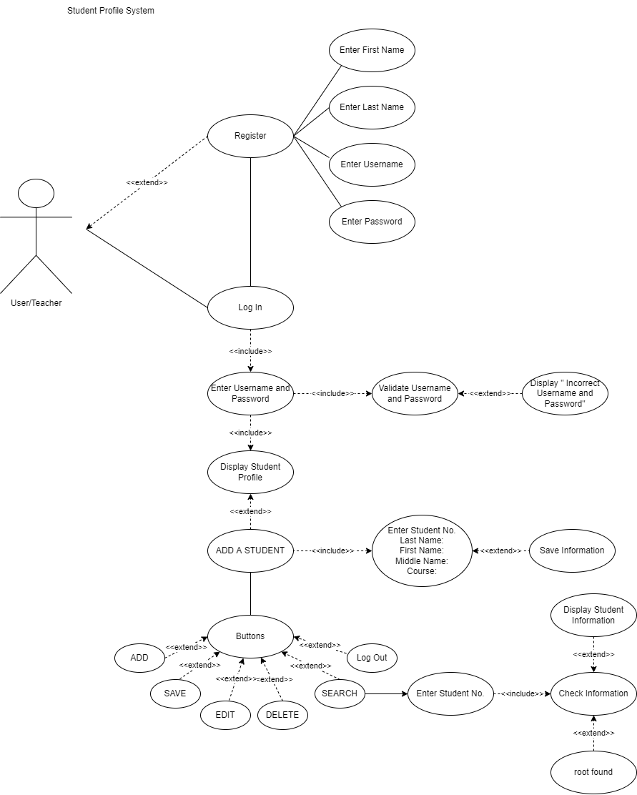

Data Flow Diagram (DFD):

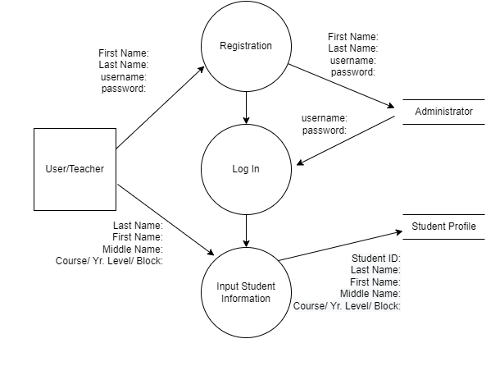

Entity Relationship Diagram (ERD):

